**CLECKSHOPHUB**

**TEAM 4**

**ERD, EERD, COMPOSITE/ DECOMPOSITE ERD**

**Team Members**

Abhishek Poudel

Amulya Shrestha

Biliyas Maharjan

Biraj Shrestha

Shasank Shrestha

Soya Shrestha

Sushan Bhandari

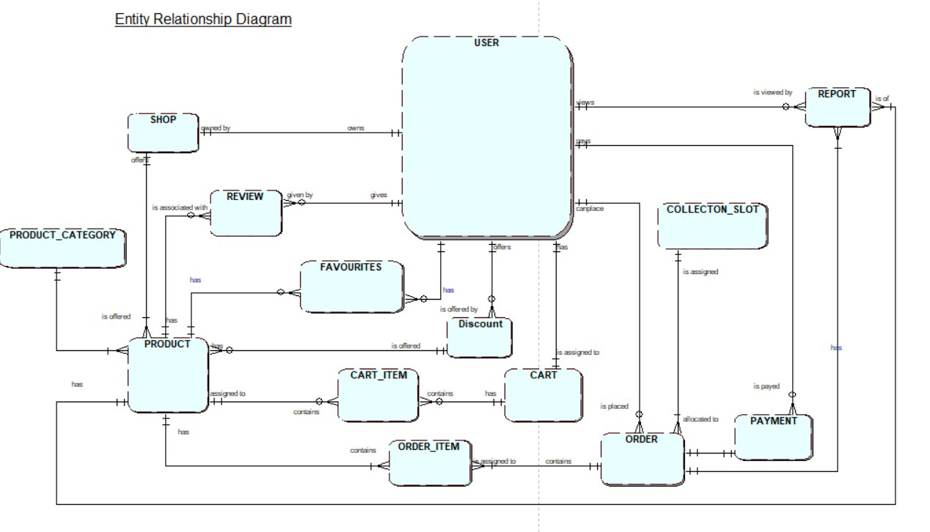

FIG1: ERD

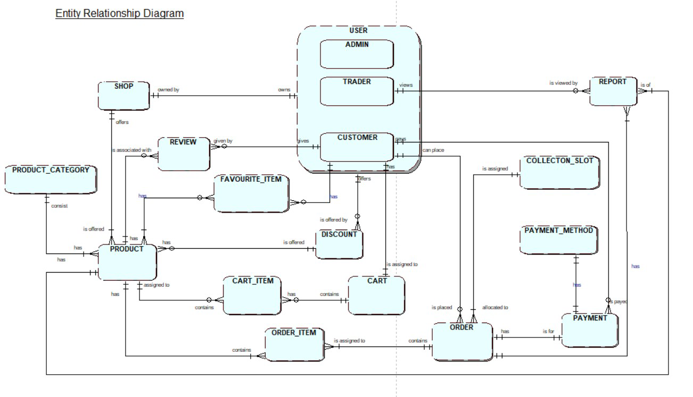

FIG2: EERD

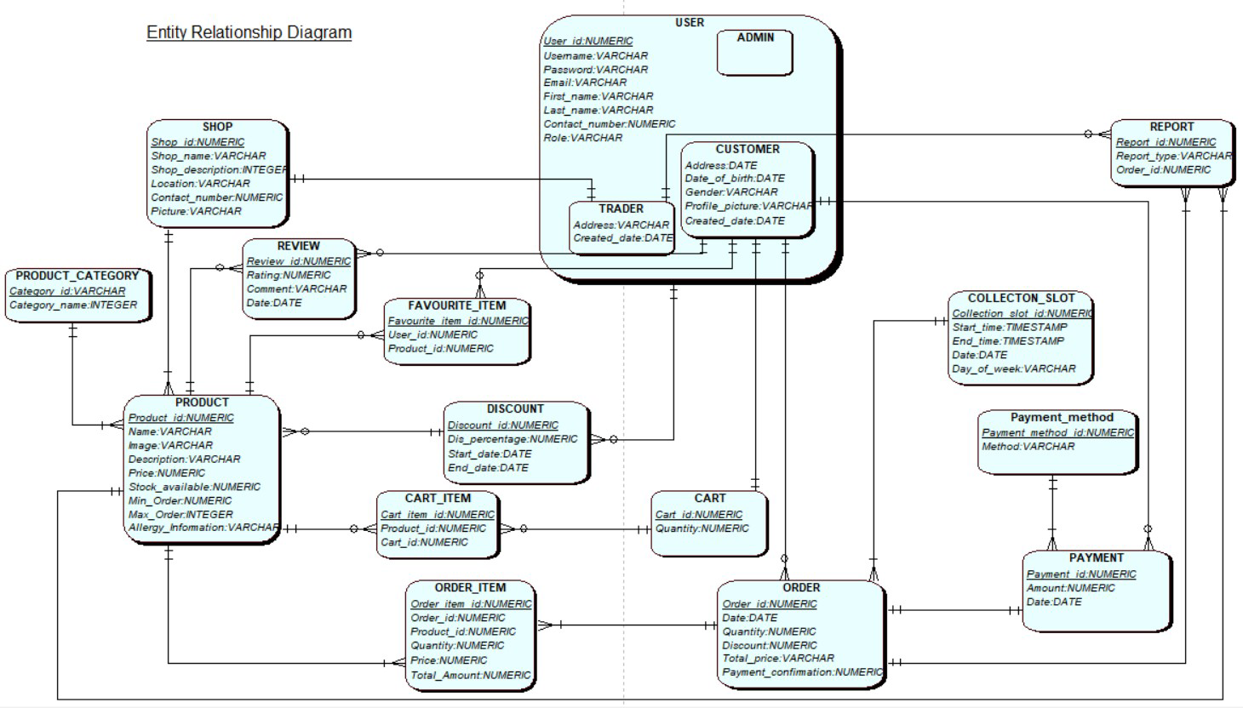

FIG: COMPOSITE ERD